# Here is how to setup for DHCP/BOOTP on your company laptop.

First, type “firewall” from the start menu and pull up “Windows Firewall with Advanced Security”

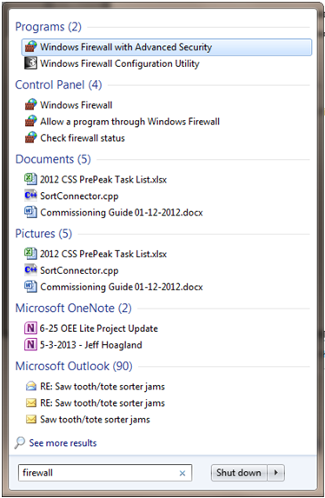

Windows Firewall with Advanced Security on Local Computer

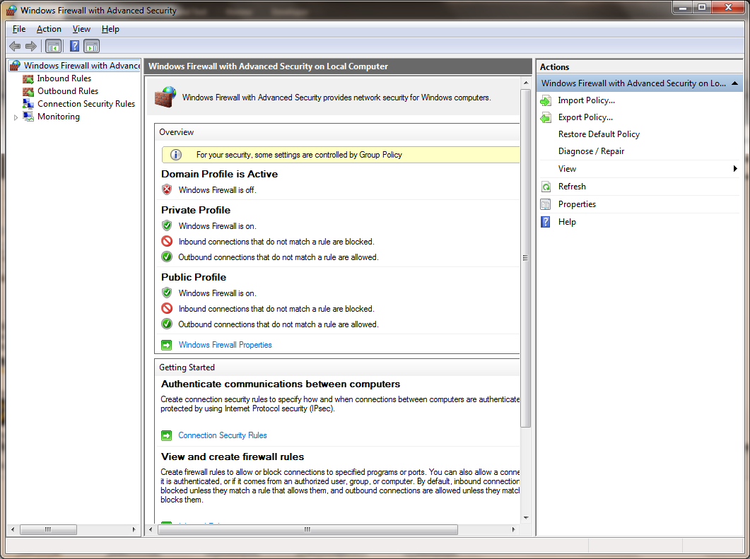

Click “Inbound Rules”

Then “New Rule”

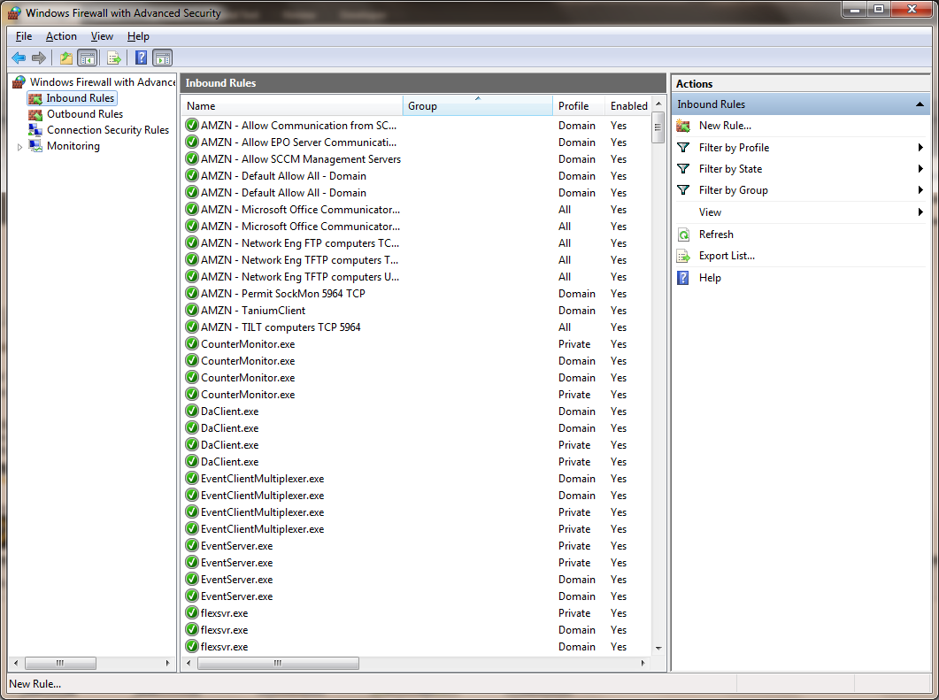

Select “Port”

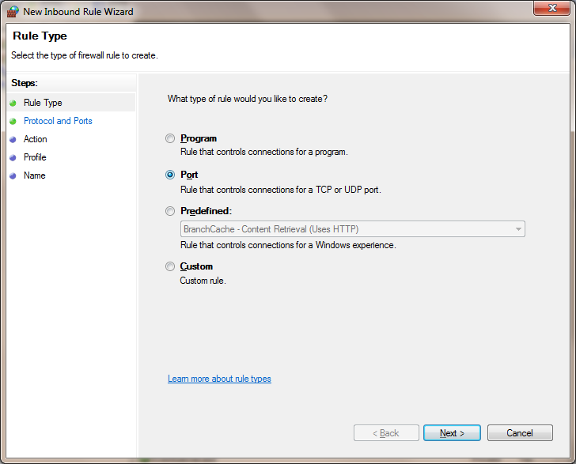

Next>

Select “UDP” and “Specific local ports:” type “67, 68”

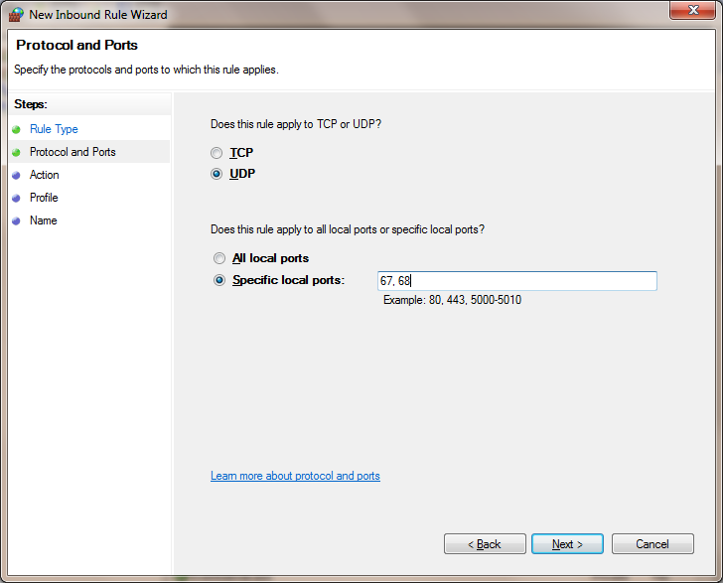

Next >

“Allow the Connection”

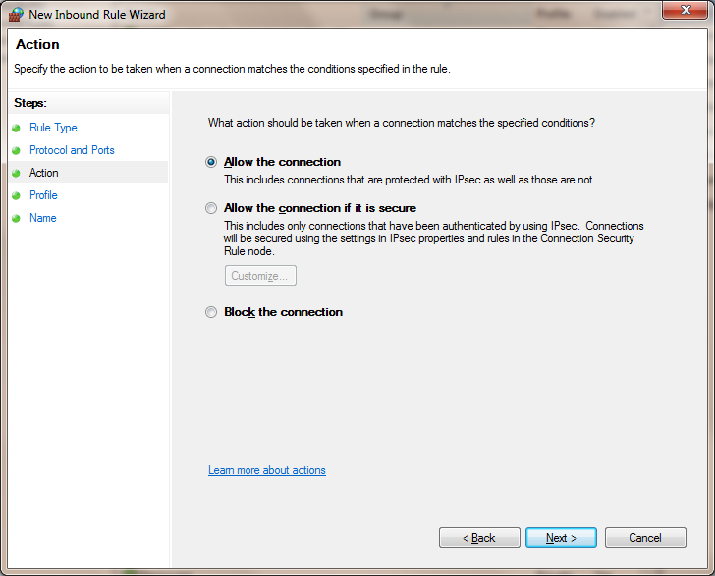

Next >

Default

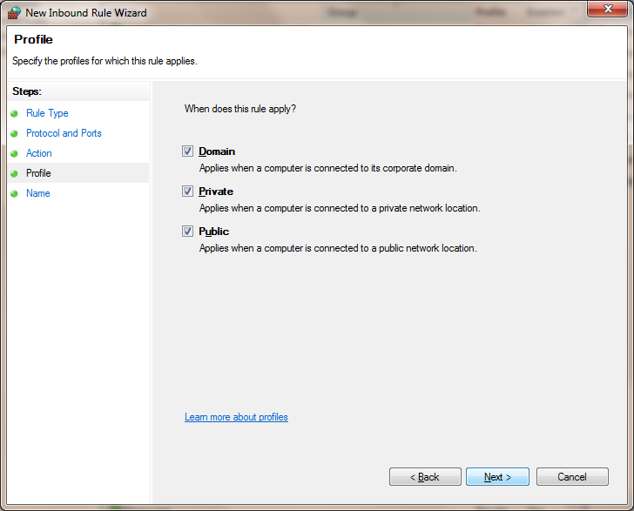

Next >

Give it a Name then Finish

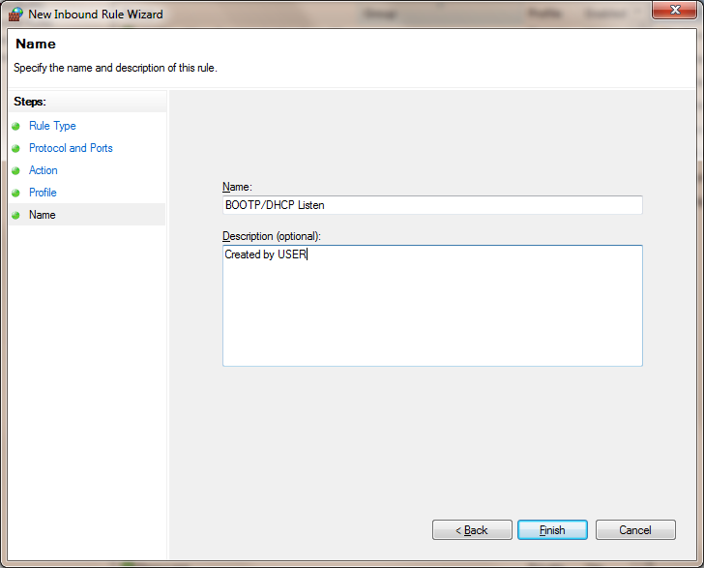

Finish Inbound Rule

Next > Now go to “Outbound rules”

Click “Outbound Rules”

Then “New Rule”

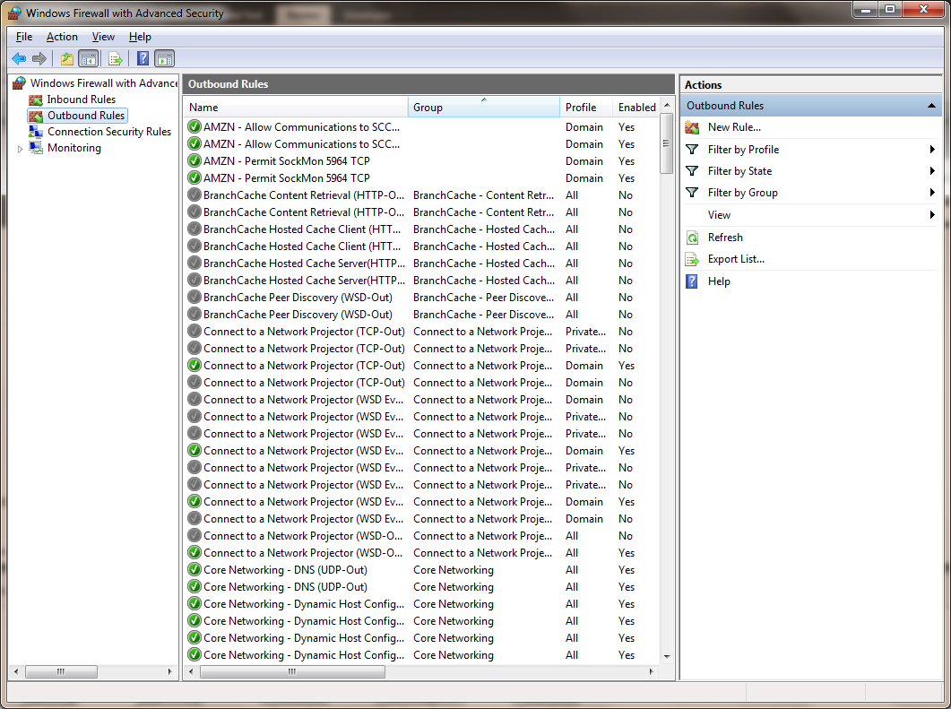

Select “Port”

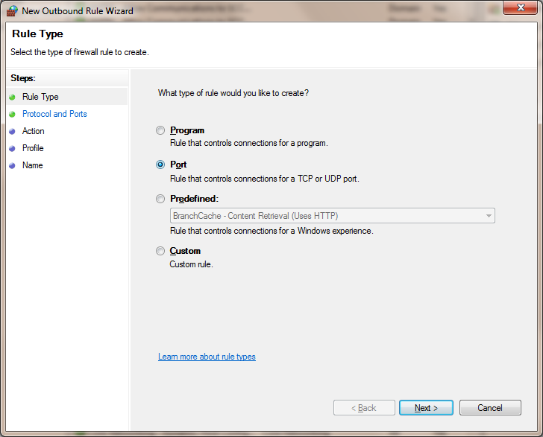

Next >

Set “UDP”

Set “Specific remote ports:” type “67, 68” 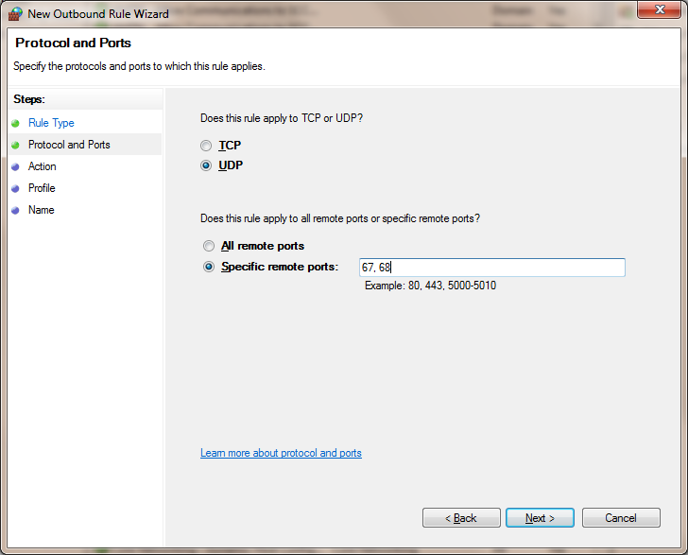

Next >

Select “Allow the Connection”

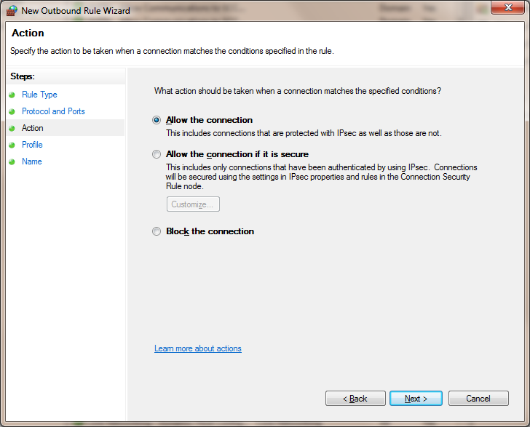

Next>

Default

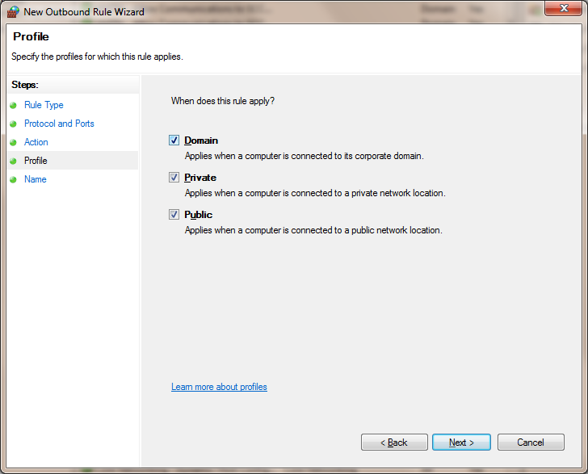

Next>

Give it a Name then Finish

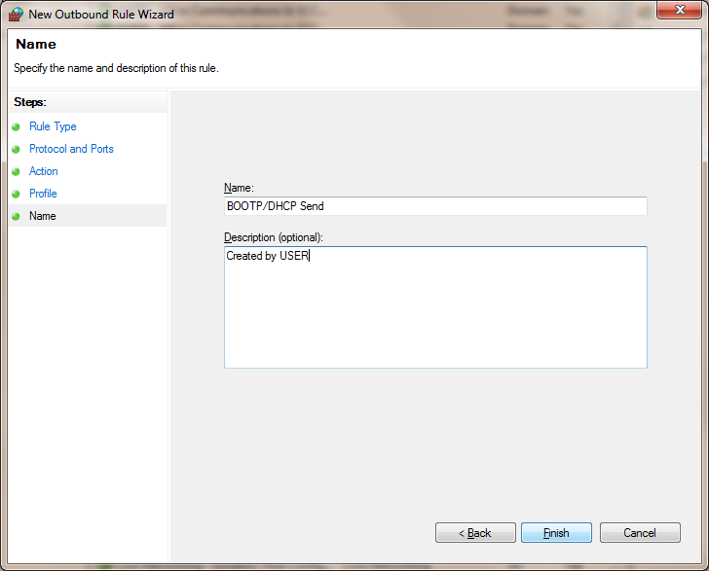

Finish

Next > Set Ethernet Port on Laptop

Set IPv4 of your Ethernet port to “obtain IP address automatically”

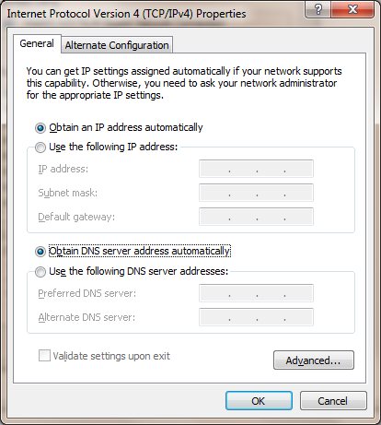

Run BOOTP with Wi-Fi off!

Once IP is set change IPv4 to match same VLAN as the set IP, then you can disable BOOTP on the device.

Enable / Disable Rule

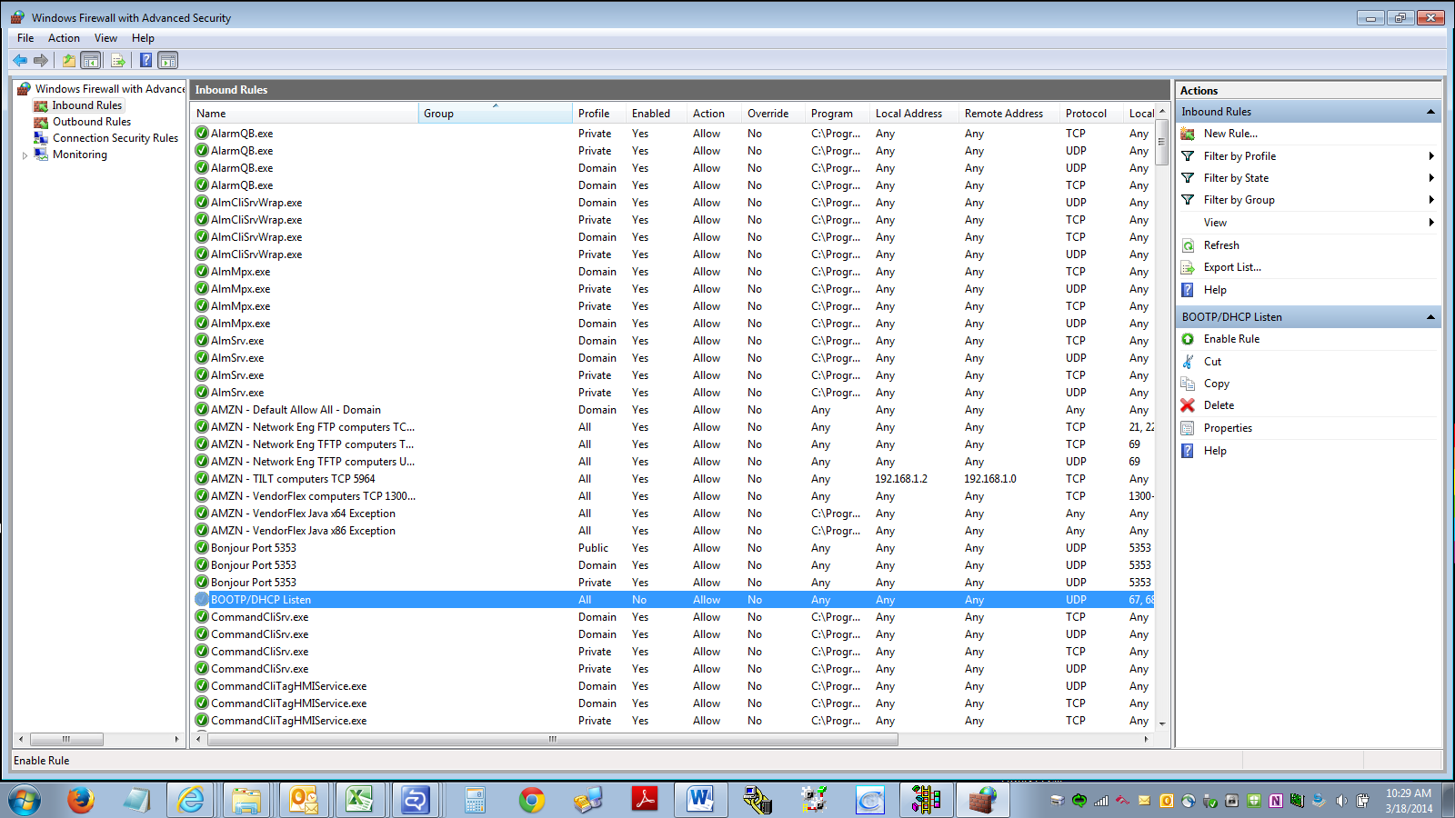

To enable or disable the Inbound Rule, click Inbound Rule then click the name of the rule (BOOTP/DHCP Listen) to highlight. Click Enable Rule or Disable Rule as shown by the arrow on the right

To enable or disable the Outbound Rule, click Outbound Rule then click the name of the rule (BOOTP/DHCP Send) to highlight. Click Enable Rule or Disable Rule as shown by the arrow on the right

The text will change to Disable Rule if it was enabled or to Enable Rule if it was disabled